**AIR POLLUTION MONITORING SYSTEM**

**ABSTRACT:**

The level of pollution is increasing rapidly due to factors like industries, urbanization, increasing in population, vehicle use which can affect human health. IOT Based Air Pollution Monitoring System is used to monitor the Air Quality over a web server using Internet. It will display alert message in LCD display, when the air quality goes down beyond a certain level, means when there are sufficient amount of harmful gases present in the air like CO2, smoke, alcohol, benzene, NH3 and NOx. It will show the air quality in PPM on the LCD and as well as on webpage so that air pollution can be monitored very easily. The system uses MQ135 sensor for monitoring Air Quality and DHT sensor for monitoring Temperature and Humidity sensor ,as it detects most harmful gases and can measure their amount accurately.

**WORKING MODEL:**

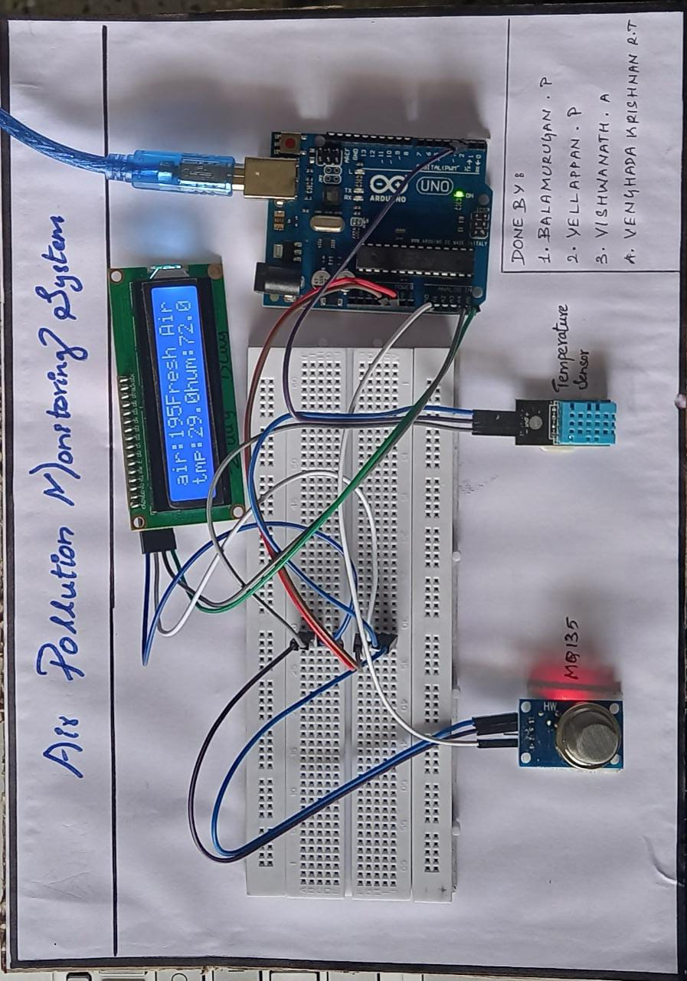

BY..

YELLAPPAN P

INTERNET OF THINGS (Project)

**THANK YOU**